

**CAPSTONE PROJECT REPORT**

**Report 6 – Software User Guides**

– Ho Chi Minh City, December 2025–

**Table of Contents**

I. Project Report 4

1. Status Report 4

2. Team Involvements 4

II. Release Package & User Guides 4

1. Deliverable Package 4

1.1 Source codes & documents 4

1.2 Known Issues, Limitations & Restrictions 5

2. Installation Guides 5

2.1 System Requirements 5

2.1.1 Hardware Requirements 5

2.1.2 Software Requirements 5

2.2 Setup Files 6

2.2.1 Database Files 6

2.2.2 Backend Files 6

2.2.3 Frontend Files 6

2.2.4 Configuration Files 6

2.3 Installation Instruction 6

2.3.1 Setup Environment 6

2.3.2 Setup Database 9

2.3.3 Setup and Run Backend API 10

2.3.4 Setup and Run Frontend Web Application 12

2.3.5 Deployment to Production (Optional) 13

3. User Manual 15

3.1 Terms and definitions 15

3.2 System requirements 16

3.3 Application Usage 17

a. Overview 17

b. Feature 1: Authentication & User Management 17

c. Feature 2: Admin - Course Management 17

d. Feature 3: Admin - Class Management 17

e. Feature 4: Instructor - Quiz Management 18

f. Feature 5: Simulation Practice 29

3.4 Troubleshooting 32

# I. Project Report

## 1. Status Report

|  |  |  |  |
| --- | --- | --- | --- |
| **#** | **Work Item** | **Status** | **Notes (Work Item in Details)** |
| 1 | Delivery packages | Completed |  |
| 2 | Installation Guides | Completed |  |
| 3 | User Manual | Completed |  |

## 2. Team Involvements

|  |  |  |  |
| --- | --- | --- | --- |
| **#** | **Task** | **Member** | **Notes (Task Details, etc.)** |
| 1 | User Manual | NhatDM |  |
| 2 | Installation Guides | KhoiPD |  |
| 3 | Delivery packages | DucDT |  |

# II. Release Package & User Guides

## 1. Deliverable Package

### 1.1 Source codes & documents

| **No.** | **Items** | **Sub-Items** | **Type** | **Version** |
| --- | --- | --- | --- | --- |
| **Code Package** | | | | |
| 1 | LSSCTC Backend API | Web Service | Modify | 10.5 |
| 2 | LSSCTC Frontend Web App | User Web Application | Modify | 9.3 |
| 3 | LSSCTC Simulator Desktop App | User Desktop Application | Modify | 3.0 |
| **Database** | | | | |
| 1 | Tables | lssctc_db_script.sql | Modify | N/A |
| **Documents** | | | | |
| 1 | Project  Introduction | Report1_Project Introduction.docx | Modify | 1.0 |
| 2 | Project  Management  Plan | Report2_Project Management Plan.docx | Modify | 1.0 |
| 3 | Software  Requirement  Specification | Report3_Software Requirement Specification.docx | Modify | 1.0 |
| 4 | Software  Design  Document | Report4_Software Design Document.docx | Modify | 1.0 |
| 5 | Test  Documentation | Report5_Test Documentation.docx | Modify | 1.0 |
| 6 | Software User  Guides | Report6_Software User Guides.docx | Modify | 1.0 |
| 7 | Final Project  Report | Report7_FinalProjectReport.docx | Modify | 1.0 |

### 1.2 Known Issues, Limitations & Restrictions

* npm install fails: Delete the node_modules folder and package-lock.json file, then run npm install again.
* Port 5173 already in use: Stop the process currently using the port or change the port number in the vite.config.js file.
* API calls fail with CORS error: Verify that the backend server is running and configured to accept requests from http://localhost:5173.
* Google OAuth not working: Ensure the Client ID in the .env file is correct and the Redirect URIs in the Google Cloud Console match your local URL.
* Blank page appears after loading: Open the browser developer tools console to check for JavaScript errors or missing environment variables.
* Module not found errors: Run npm install again to ensure all required dependencies are downloaded.

## 2. Installation Guides

### 2.1 System Requirements

#### 2.1.1 Hardware Requirements

|  |  |  |
| --- | --- | --- |
| **Component** | **Minimum** | **Recommended** |
| CPU | At least 2 GHz x64-bit CPU | Intel Core I5, 4GHz |
| Memory | At least 8GB RAM | 16GB RAM |
| Storage | 10GB SSD | 15GB SSD |
| Network | Internet Connection | 500 Mbps |

**Table 1: Hardware Requirements**

#### 2.1.2 Software Requirements

|  |  |  |
| --- | --- | --- |
| **Component** | **Software & Version** | **Description** |
| Operating System | Windows 10/11, macOS 10.15+, or Linux (Ubuntu 20.04+) | Operating system for running project |
| DBMS | SQL Server 2019 or Azure SQL Database | Database management system |
| Server Environment | .NET 8.0 SDK | Environment for running backend API |
| Frontend Environment | Node.js 18.17.0 or higher | Environment for running frontend application |
| Package Manager | NPM 9.x or higher | Package manager for frontend dependencies |
| IDE | Visual Studio Code 1.80+ or Visual Studio 2022 | Tool for viewing and editing code |
| VCS | Git 2.30+ | Tool for managing code version |
| Web Browser | Chrome 90+, Firefox 88+, Edge 90+, or Safari 14+ | Browser for accessing web application |
| Database Tool | SQL Server Management Studio (SSMS) 19+ or Azure Data Studio | Tool for database management |

**Table 2: Software Requirements**

### 2.2 Setup Files

#### 2.2.1 Database Files

* **lssctc_db-script-v5.sql**: Complete database schema script for SQL Server
* **seed-data.sql**: Initial seed data for system (users, roles, course categories, etc.)

#### 2.2.2 Backend Files

* **lssctc-api. zip**: Complete backend API solution
  + Contains: Controllers, Services, Models, Repositories, and Configuration files
  + Main project: Lssctc.ProgramManagement
  + Shared library: Lssctc.Share

#### 2.2.3 Frontend Files

* **lssctc-web.zip**: Complete frontend web application
  + Contains: React components, Pages, Routes, Layouts, and Assets
  + Main entry: src/main.jsx
  + Configuration: vite.config.js, package.json

#### 2.2.4 Configuration Files

* **appsettings.json**: Backend API configuration (connection strings, JWT settings)
* **appsettings.Development.json**: Development-specific settings
* **.env. example**: Frontend environment variables template

### 2.3 Installation Instruction

#### 2.3.1 Setup Environment

**Step 1: Install Required Software**

* **Download and Install .NET 8.0 SDK**
  + Visit: <https://dotnet.microsoft.com/download/dotnet/8.0>
  + Download . NET 8.0 SDK for your operating system
  + Run installer and follow installation wizard
* **Download and Install Node.js 18.17.0 or higher**
  + Visit: <https://nodejs.org/>
  + Download LTS version (18.17.0 or newer)
  + Run installer and follow installation wizard
* **Download and Install SQL Server 2019**
  + Visit: <https://www.microsoft.com/en-us/sql-server/sql-server-downloads>
  + Download SQL Server 2019 Developer Edition (free)
  + Run installer and select:
    - Database Engine Services
    - SQL Server Replication
    - Client Tools Connectivity
  + Configure authentication mode: **Mixed Mode** (SQL Server and Windows Authentication)
  + Set SA password (remember this for connection string)
  + Verify installation using SQL Server Configuration Manager
* **Download and Install SQL Server Management Studio (SSMS)**
  + Visit: <https://docs.microsoft.com/en-us/sql/ssms/download-sql-server-management-studio-ssms>
  + Download latest version (19.x)
  + Run installer
  + Launch SSMS and connect to local SQL Server instance
* **Download and Install Visual Studio Code**
  + Visit: <https://code.visualstudio.com/>
  + Download for your operating system
  + Install recommended extensions:
    - C# Dev Kit
    - C# Extensions
    - JavaScript (ES6) code snippets
    - ESLint
    - Prettier - Code formatter
    - Thunder Client (for API testing)
* **Download and Install Git**
  + Visit: <https://git-scm.com/downloads>
  + Download for your operating system
  + Run installer with default options

**Step 2: Configure Git**

* Set your name and email
  + git config --global user.name "Your Name"
  + git config --global user.email "your. email@example.com"
* Verify configuration
  + git config --list

**Step 3: Connect Git with GitHub Account**

* Generate SSH key (if not already exists)
  + ssh-keygen -t ed25519 -C "your.email@example.com"
* Start SSH agent
  + eval "$(ssh-agent -s)"
* Add SSH key to agent
  + ssh-add ~/.ssh/id_ed25519
* Copy public key to clipboard (Windows)
  + clip < ~/.ssh/id_ed25519.pub
* Copy public key to clipboard (macOS)
  + pbcopy < ~/.ssh/id_ed25519.pub
* Copy public key to clipboard (Linux)
  + cat ~/.ssh/id_ed25519.pub | xclip -selection clipboard
* Go to GitHub → Settings → SSH and GPG keys → New SSH key
* Paste your public key and save

**Step 4: Clone Repositories**

* Create project directory
  + mkdir lssctc-project
  + cd lssctc-project
* Clone backend repository
  + git clone https://github.com/hieuvau198/lssctc-api.git
* Clone frontend repository
  + git clone https://github.com/hieuvau198/lssctc-web.git

#### 2.3.2 Setup Database

**Step 1: Create Database**

* Open **SQL Server Management Studio (SSMS)**
* Connect to your local SQL Server instance
* Right-click on **Databases** → Select **New Database**
* Database name: LSSCTC_DB
* Click **OK**

**Step 2: Execute Database Script**

* Open **lssctc_db-script-v5.sql** in SSMS
  + File → Open → File → Select lssctc_db-script.sql
* Ensure **LSSCTC_DB** is selected in database dropdown
* Click **Execute** button or press F5
* Wait for script execution to complete
* Verify tables are created:
* USE LSSCTC_DB;
* GO
* SELECT TABLE_SCHEMA, TABLE_NAME
* FROM INFORMATION_SCHEMA.TABLES
* WHERE TABLE_TYPE = 'BASE TABLE'
* ORDER BY TABLE_NAME;
* Expected output: 40+ tables including users, roles, courses, classes, quizzes, etc.

**Step 3: Execute Seed Data (Optional)**

* Open **seed-data.sql** in SSMS
* Execute script to populate initial data:
  + Default admin account
  + Course categories and levels
  + Course and class codes
  + Material types
* Verify seed data:
* SELECT * FROM users;
* SELECT * FROM course_categories;
* SELECT * FROM course_levels;

**Step 4: Verify Database Connection String**

* Server name: localhost or (local) or .
* Database name: LSSCTC_DB
* Authentication: SQL Server Authentication or Windows Authentication
* Example connection string:
* Server=localhost;Database=LSSCTC_DB;User Id=sa;Password=YourPassword;TrustServerCertificate=True

#### 2.3.3 Setup and Run Backend API

**Step 1: Navigate to Backend Project**

* cd lssctc-project/lssctc-api/Lssctc/Lssctc.ProgramManagement

**Step 2: Configure Application Settings**

* Open **appsettings.json** in text editor or VS Code
* Update your custom value for: "ConnectionStrings", "JwtConfig", "EmailSettings"
* **Generate JWT Secret Key** (recommended):
  + Generate random 32-character key using PowerShell (Windows)
  + Generate random 32-character key using openssl (macOS/Linux)
* **Configure Email Settings** (for OTP functionality):
  + Use Gmail account
  + Enable 2-Factor Authentication
  + Generate App Password: <https://myaccount.google.com/apppasswords>
  + Use App Password in configuration (not your Gmail password)

**Step 3: Restore NuGet Packages**

* Restore all dependencies
  + dotnet restore

**Step 4: Build Project**

* Build project
  + dotnet build
  + Expected output: Build succeeded.

**Step 5: Run Backend API**

* Run in development mode
  + dotnet run

**Step 6: Verify API is Running**

* Open web browser
* Navigate to: **<http://localhost:5000/swagger>**
* You should see Swagger UI with all API endpoints

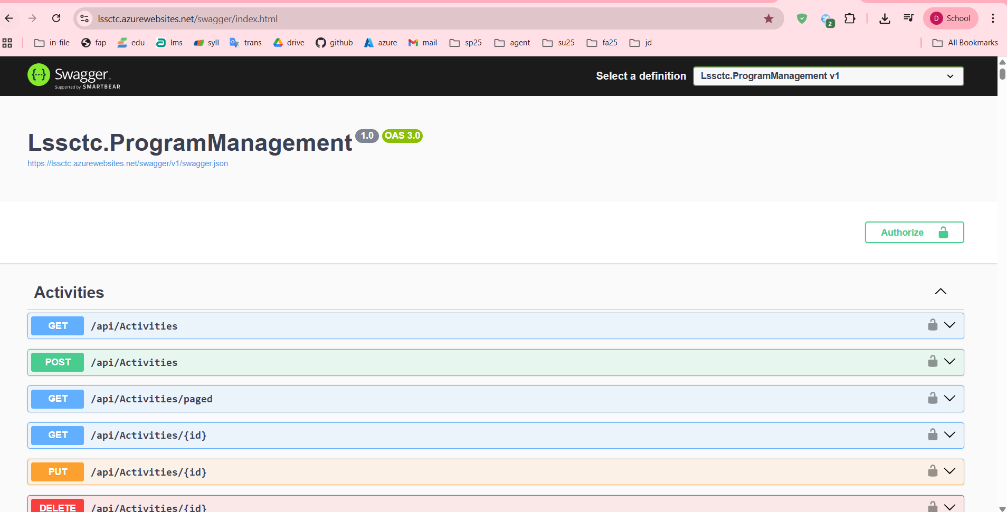

File: screenshot_swagger_ui_homepage.png

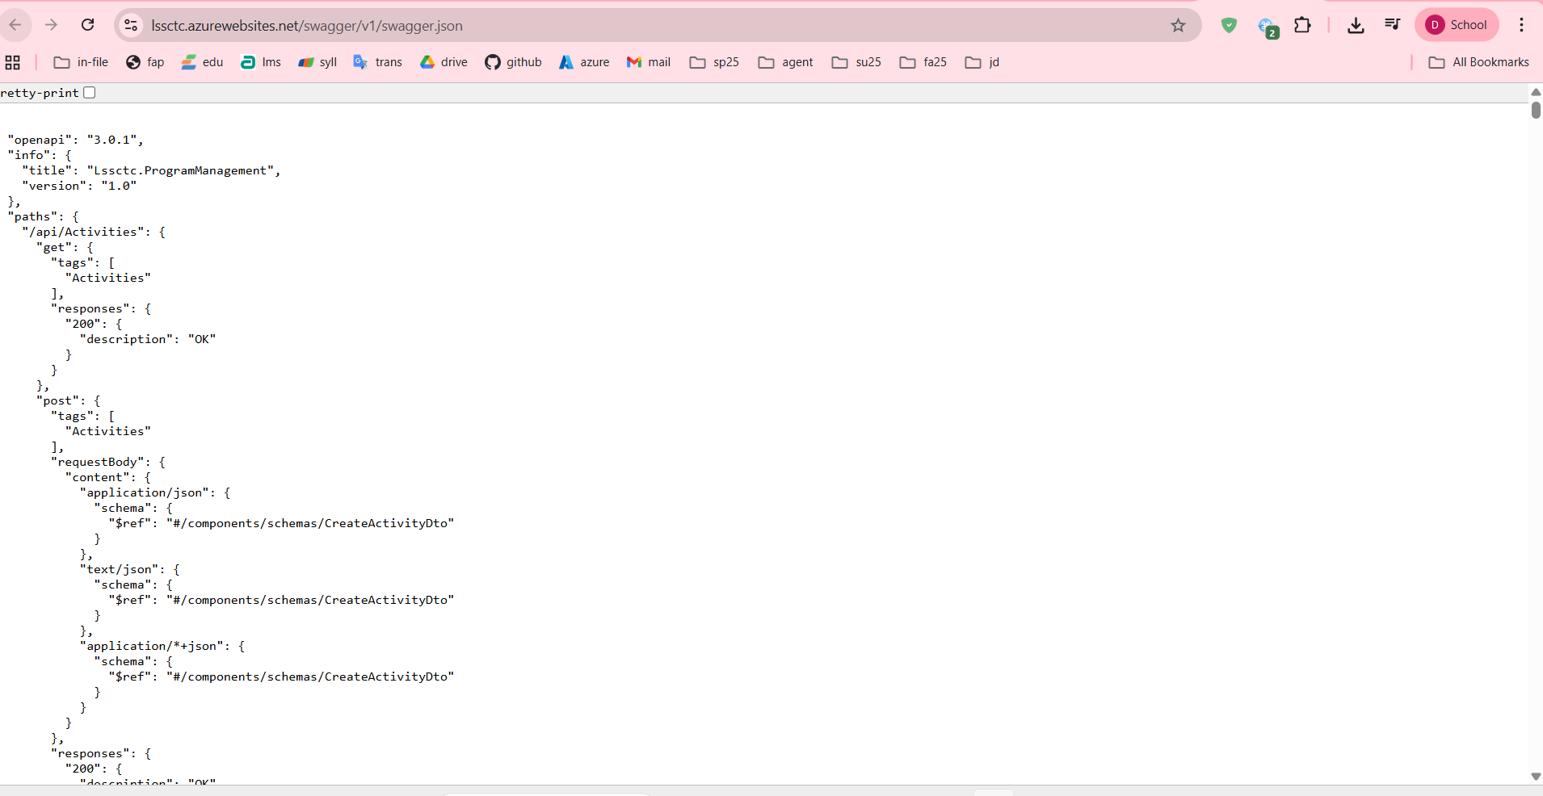

1. Test authentication endpoint:
   * Expand **POST /api/Authens/login-username**
   * Click **Try it out**
   * Enter test credentials (if seeded)
   * Click **Execute**
   * Verify 200 OK response with JWT token

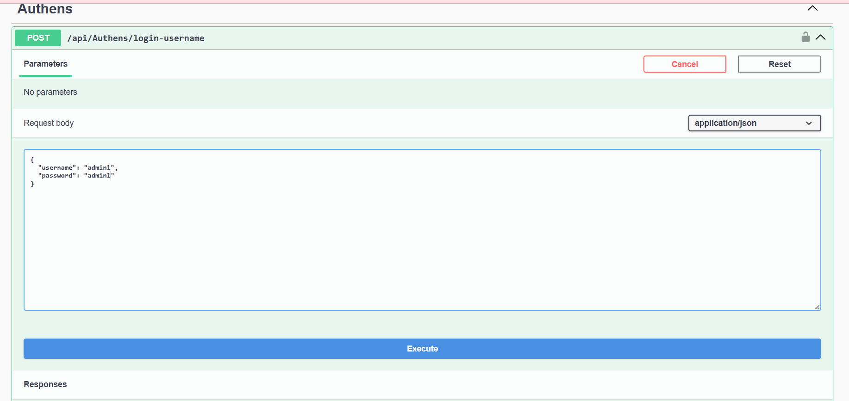

#### 2.3.4 Setup and Run Frontend Web Application

This section outlines how to configure, run, and verify the frontend client interface.

Step 1: Installation

* Navigate to the project directory and install the required dependencies.

Step 2: Environment Configuration

* Set up the connection to the backend and external services.
* Create the configuration file:
* Windows: copy .env.example .env
* macOS/Linux: cp .env.example .env
* Edit the .env file
* Optional: Google OAuth Setup To enable "Sign in with Google," create a project in the Google Cloud Console:
* Type: OAuth 2.0 Web Application
* Origin: http://localhost:5173
* RedirectURI: http://localhost:5173/auth/callback
* Action: Paste the generated Client ID into your .env file.

Step 5: Production Build (Optional)

* To prepare the application for final deployment:
* Build: Run npm run build to generate the dist/ folder.
* Preview: Run npm run preview to test the build at http://localhost:5173.

#### 2.3.5 Deployment to Production

**Backend Deployment Options:**

**Option 1: Deploy to Azure App Service**

1. Install Azure CLI
2. Login to Azure:
3. az login
4. Create App Service:
5. az webapp create --resource-group myResourceGroup --plan myAppServicePlan --name lssctc-api --runtime "DOTNET:8.0"
6. Deploy:
7. dotnet publish -c Release
8. az webapp deploy --resource-group myResourceGroup --name lssctc-api --src-path ./bin/Release/net8.0/publish. zip
9. Configure connection string in Azure Portal
10. Update JWT and Email settings

**Option 2: Deploy to Docker Container**

1. Create Dockerfile in backend project root:
2. FROM mcr.microsoft.com/dotnet/aspnet:8.0
3. WORKDIR /app
4. COPY ./publish .
5. ENTRYPOINT ["dotnet", "Lssctc.ProgramManagement.dll"]
6. Build and run:
7. dotnet publish -c Release -o ./publish
8. docker build -t lssctc-api .
9. docker run -p 5000:80 lssctc-api

**Frontend Deployment Options:**

**Option 1: Deploy to Vercel**

1. Install Vercel CLI:
2. npm install -g vercel
3. Login:
4. vercel login
5. Deploy:
6. vercel --prod
7. Configure environment variables in Vercel dashboard

**Option 2: Deploy to Azure Static Web Apps**

1. Build production bundle:
2. npm run build
3. Create Static Web App in Azure Portal
4. Connect to GitHub repository
5. Configure build settings:
   * App location: /
   * API location: (empty)
   * Output location: dist
6. Azure will automatically build and deploy on push

**Option 3: Deploy to Netlify**

1. Install Netlify CLI:
2. npm install -g netlify-cli
3. Build:
4. npm run build
5. Deploy:
6. netlify deploy --prod --dir=dist

**Database Deployment:**

**Deploy to Azure SQL Database**

1. Create Azure SQL Database in Azure Portal
2. Export local database using SSMS:
   * Right-click database → Tasks → Generate Scripts
   * Select all objects
   * Save script
3. Connect to Azure SQL Database
4. Execute script to create schema

Update connection string in backend configuration

## 3. User Manual

### 3.1 Terms and definitions

|  |  |
| --- | --- |
| **Term** | **Definition** |
| LSSCTC | Learner Management and 3D Simulation System for Crane Training Center |
| Admin | System administrator with full access to all features and user management |
| Instructor | Teacher/trainer who creates course content, quizzes, and evaluates trainees |
| Trainee | Student enrolled in crane operation training courses |
| Program Manager | Role responsible for curriculum design and course orchestration |
| Simulation Manager | Role responsible for managing 3D simulation components and scenarios |
| Training Program | Complete curriculum consisting of multiple courses leading to certification |
| Course | Individual training module covering specific crane operation topics |
| Section | Subdivision within a course containing organized activities |
| Activity | Learning task within a section (material, quiz, or practice) |
| Learning Material | Educational content (PDF, video, image, URL) provided to trainees |
| Quiz | Assessment containing multiple-choice or single-choice questions |
| Practice | Hands-on simulation task for skill development and evaluation |
| Class | Group of trainees enrolled in a program with scheduled sessions |
| Timeslot | Scheduled session for class instruction with date, time, and instructor |
| Enrollment | Trainee's registration and participation in a specific class |
| Activity Record | Trainee's progress and completion status for an activity |
| Quiz Attempt | Trainee's submission of a quiz with scored results |
| Practice Attempt | Trainee's completion of a practice session with performance metrics |
| Simulation Component | 3D model or asset used in crane operation simulation environment |
| Brand Model | Specific crane manufacturer and model configuration |
| JWT | JSON Web Token - authentication token for API access |
| OTP | One-Time Password - 6-digit code for password reset verification |
| WebGL | Web Graphics Library - browser technology for 3D rendering |

### 3.2 System requirements

For End Users (Trainees, Instructors):

* Operating System:
  + Windows 10/11 (64-bit)
  + macOS 10.15 (Catalina) or later
  + Linux (Ubuntu 20.04+ or equivalent)
* Web Browser:
  + Google Chrome 90+ (Recommended)
  + Mozilla Firefox 88+
  + Safari 14+ (macOS only)
  + Microsoft Edge 90+
* Internet Connection:
  + Minimum: 5 Mbps (for video streaming and general use)
  + Recommended: 10 Mbps (for 3D simulation)
* Display Resolution:
  + Minimum: 1366x768
  + Recommended: 1920x1080 or higher
* Input Devices:
  + Mouse and keyboard (required)
  + Trackpad supported but not recommended for simulation

For Simulation Features:

* RAM:
  + Minimum: 8GB
  + Recommended: 16GB
* Graphics Card:
  + Dedicated GPU with WebGL 2.0 support
  + NVIDIA GTX 1050 or equivalent
  + AMD Radeon RX 560 or equivalent
* Storage:
  + 2GB free space for cached 3D models and textures
* CPU:
  + Minimum: Intel Core i5 or AMD Ryzen 5
  + Recommended: Intel Core i7 or AMD Ryzen 7

For System Administrators:

* All of the above, plus:
* Access to SQL Server Management Studio or Azure Data Studio
* Network access to application server and database server

Remote desktop or SSH access to servers (for on-premise deployment)

### 3.3 Application Usage

#### a. Overview

The LSSCTC system is a web-based Learning Management System integrated with 3D crane operation simulation capabilities. It consists of:

1. Frontend (Web Application): React-based single-page application
2. Backend (API): .NET 8 RESTful API with JWT authentication
3. Database: SQL Server relational database
4. 3D Engine: WebGL-based simulation environment (planned)

#### b. Feature 1: Authentication & User Management

Purpose: Secure user authentication with multiple login methods and role-based access control

Available Functions:

1. Login with Username/Password
2. Login with Email/Password
3. Login with Google OAuth
4. Password Reset (OTP-based)
5. Logout

Profile View and Update

#### c. Feature 2: Admin - Course Management

Purpose: Create, organize, and manage training courses

Available Functions:

1. View All Courses (with pagination, search, sort)
2. Create New Course
3. Edit Course Details
4. Delete Course (soft delete)
5. Assign Course to Programs

View Course Enrollments

#### d. **Feature 3: Admin - Class Management**

Purpose: Organize trainees into classes, assign instructors, and manage schedules

Available Functions:

1. View All Classes
2. Create New Class
3. Edit Class Details
4. View Class Enrollments
5. Approve/Reject Enrollments
6. Manage Class Timeslots (Schedule)

Assign Instructors

#### e. **Feature 4: Instructor - Quiz Management**

Purpose: Create assessments to evaluate trainee knowledge and understanding

Available Functions:

1. Create Quiz with Questions
2. Import Quiz from Excel Template
3. Edit Quiz and Questions
4. Delete Quiz
5. Assign Quiz to Activity

View Quiz Attempts and Results

***Create Quiz:***

Step-by-Step Instructions:

1. Login as Instructor
2. Navigate to Instructor Dashboard
3. Click "Quizzes" in sidebar

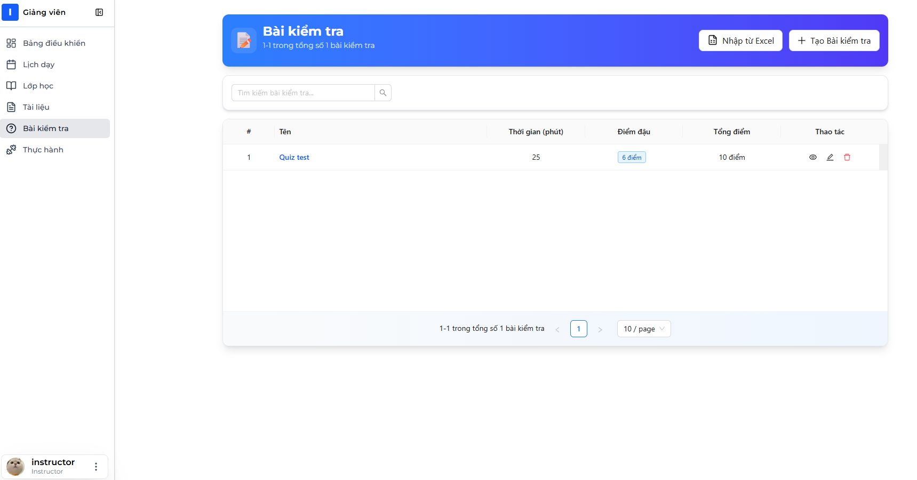

1. Quizzes list page displays showing your created quizzes



1. Click "Create New Quiz" button

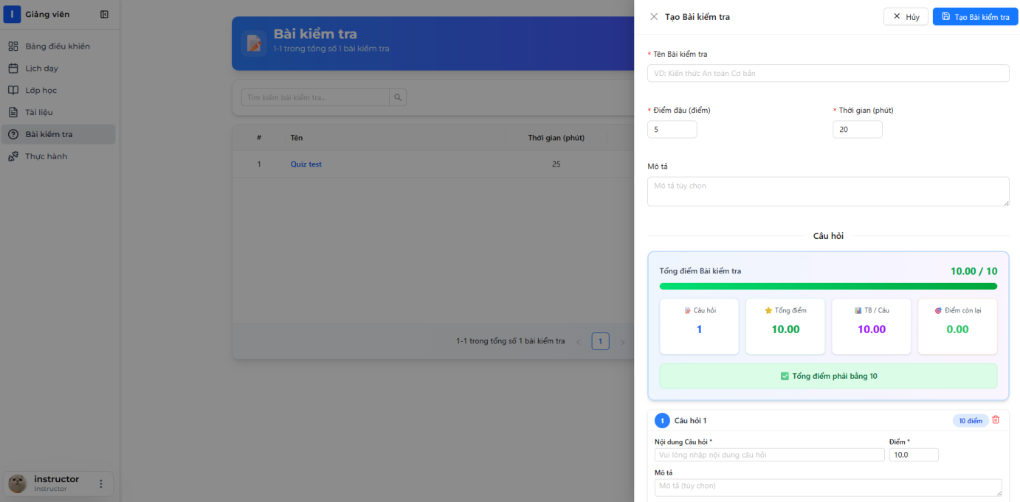

1. Quiz creation form opens (may be multi-step)

Step 1: Quiz Basic Information

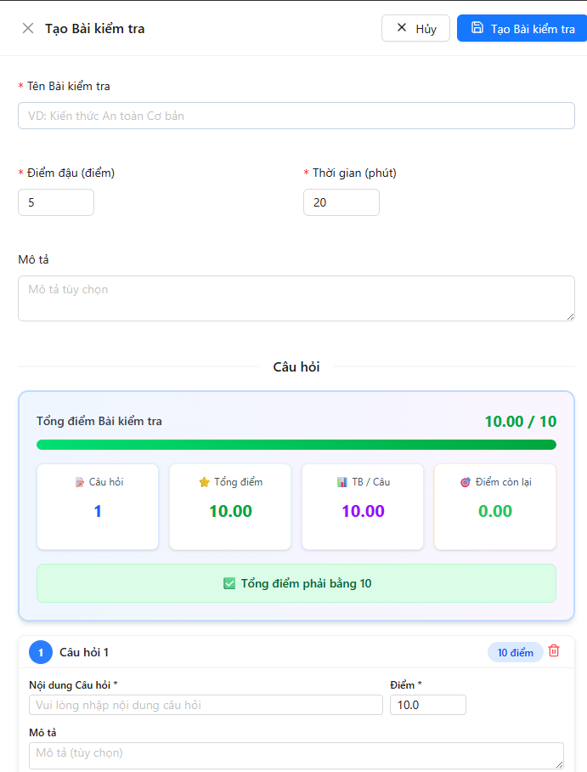

1. Fill in quiz information:
   * Quiz Name: "Mobile Crane Safety Assessment"
   * Description: "Test your knowledge of crane safety procedures"
   * Duration: 30 minutes
   * Passing Score: 7
2. Click "Next"

Step 2: Add Questions

📷 INSERT SCREENSHOT HERE: Add Questions Section

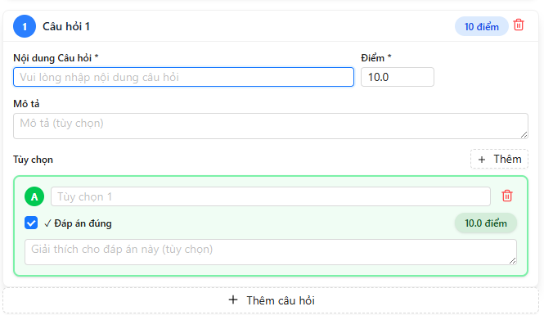

1. Click "Add Question" button
2. Question form appears



1. Fill in question details:
   * Question Text: "What is the safe minimum distance from a power line for crane operations?"
   * Score Points:10
   * Explanation: "Regulations often require at least 10 meters depending on voltage."
2. Add Options:
   * Click "Add Option" button for each option

📷 INSERT SCREENSHOT HERE: Add Option Interface

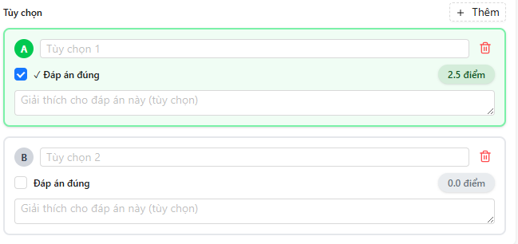

1. Enter options:
   * Option 1: "1 meter" (not correct)
   * Option 2: "3 meters" (not correct)
   * Option 3: "10 meters" (check "Is Correct")
   * Option 4: "50 meters" (not correct)

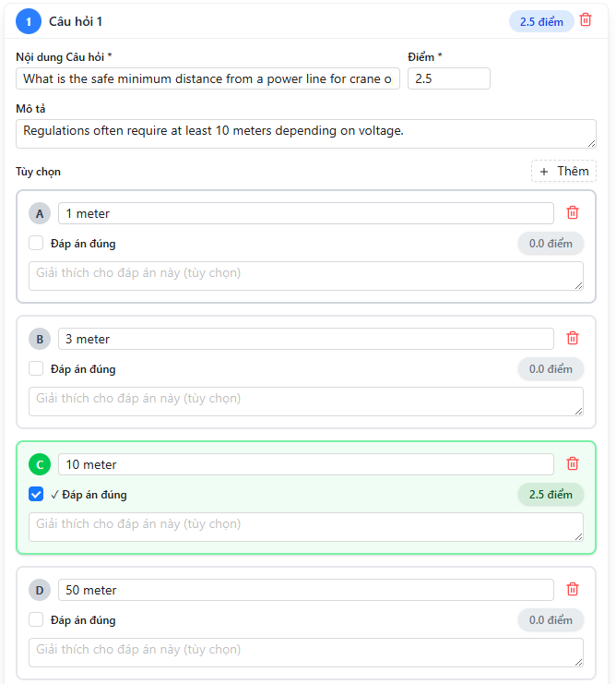

1. Click "Save Question"
2. Question is added to quiz questions list

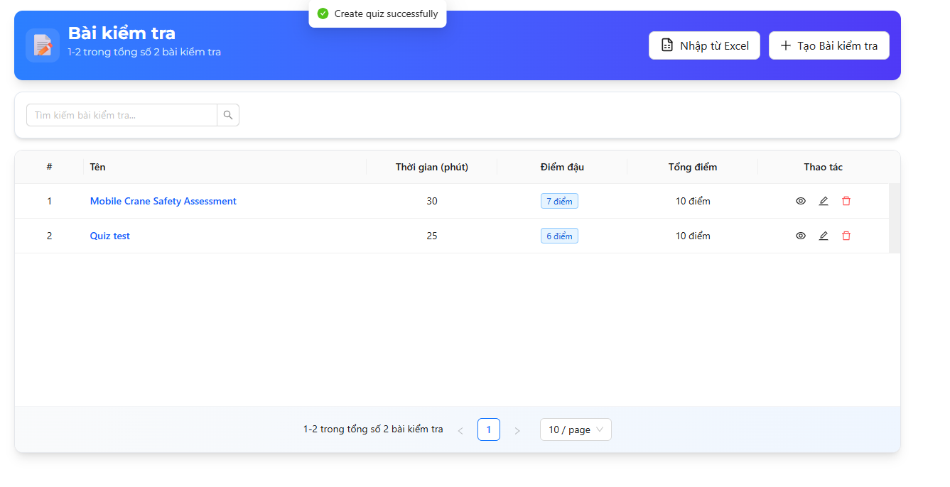

1. Repeat steps 9-15 to add more questions
   * Add at least 2-10 questions per quiz



1. Review Quiz:
   * Check all questions are added
   * Verify total points
   * Ensure at least one correct option per question
2. Click "Save Quiz" button
3. Success message: "Quiz created successfully"



API Endpoint Used:

POST /api/Quizzes/with-questions

Request Body:

{

"name": "Mobile Crane Safety Assessment",

"description": "Test your knowledge.. .",

"durationMinutes": 30,

"passingScore": 70,

"isRandomizeQuestions": true,

"isRandomizeOptions": true,

"showCorrectAnswers": true,

"isActive": true,

"questions": [

{

"questionText": "What is the safe minimum distance.. .",

"score": 2.5,

"isMultiple": false,

"explanation": "Regulations often require.. .",

"options": [

{ "optionText": "1 meter", "isCorrect": false },

{ "optionText": "3 meters", "isCorrect": false },

{ "optionText": "10 meters", "isCorrect": true },

{ "optionText": "50 meters", "isCorrect": false }

]

},

{ ... more questions... }

]

}

Response (200 OK):

{

"status": 200,

"message": "Create quiz successfully",

"data": { "quizId": 45 }

}

***Import Quiz:***

Import Quiz from Excel

Step-by-Step Instructions:

1. Download Excel template first:
   * Navigate to Quizzes page
   * Click "Import Quiz" dropdown
   * Select "Download Template"

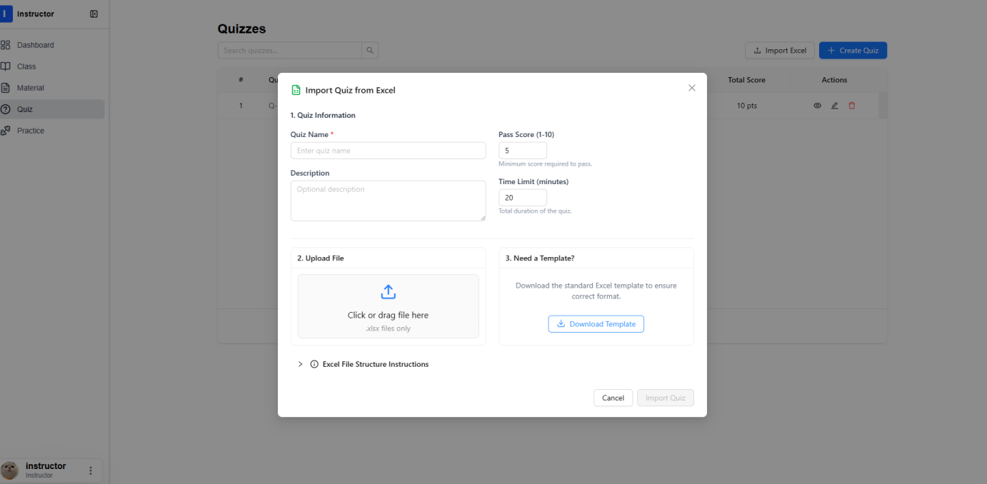

1. Template Excel file downloads

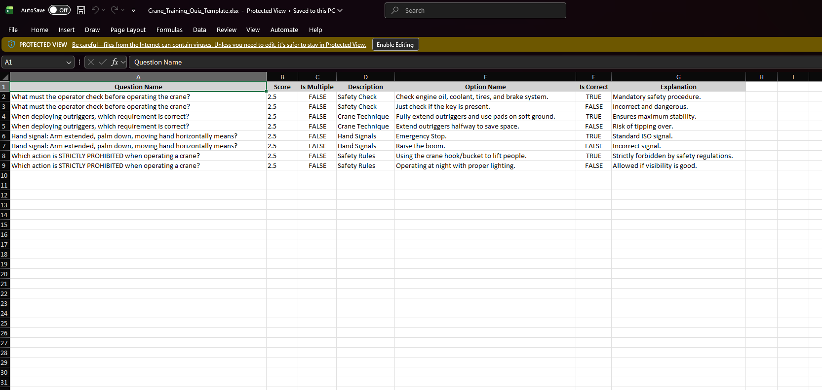

1. Fill in template:
   * Each question can have multiple rows (one per option)
   * Question Name must be same for all options of same question
   * Is Multiple: true/false
   * Is Correct: true/false (only ONE true for single choice)



1. Save Excel file as .xlsx format
2. Return to Quizzes page
3. Click "Import Quiz" → "Import from Excel"

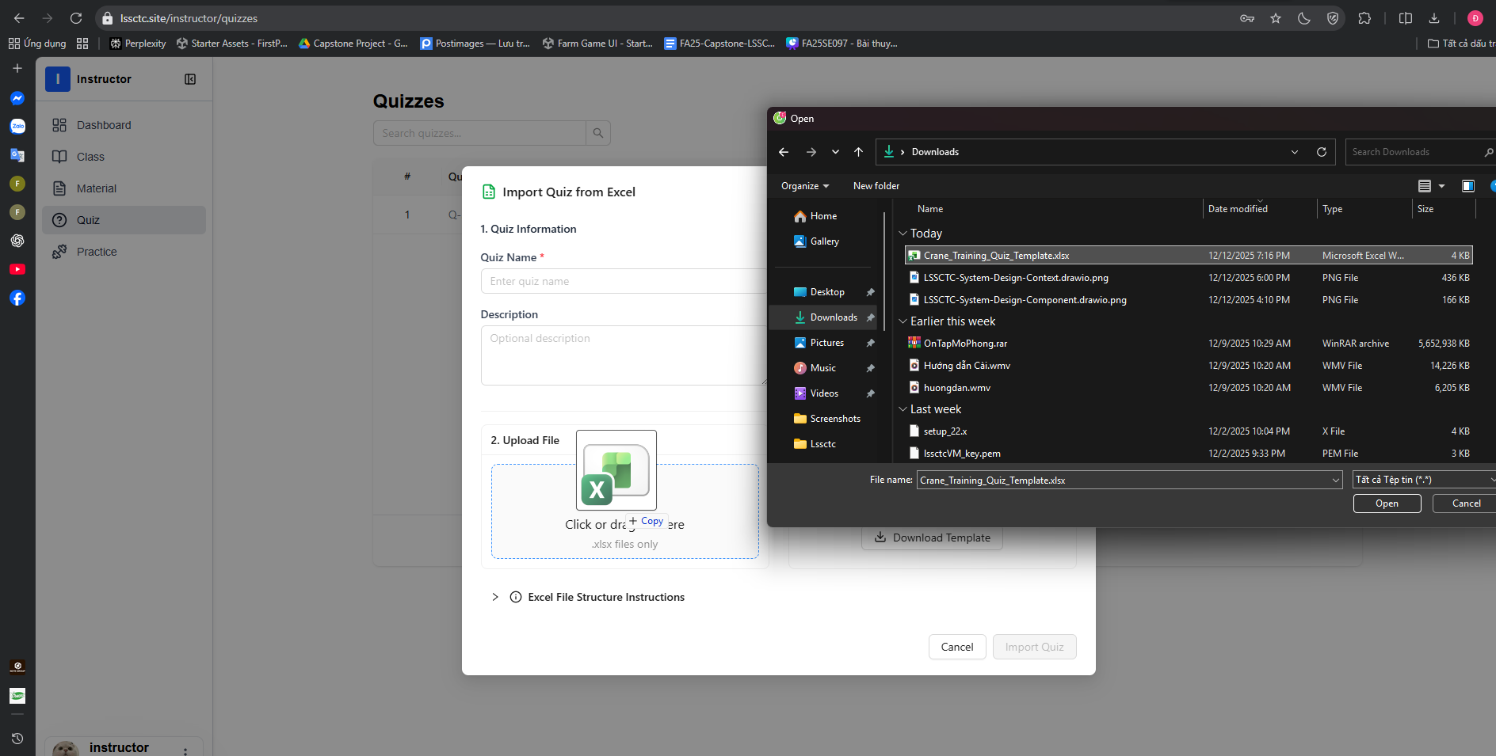

1. Drag file into drop zone or click "Browse Files"
2. Select your filled Excel file
3. File name appears in dialog

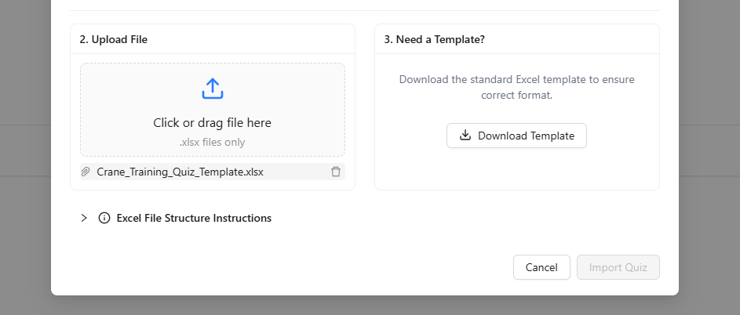

#### f. Feature 5: Simulation Practice

1. Download file exe

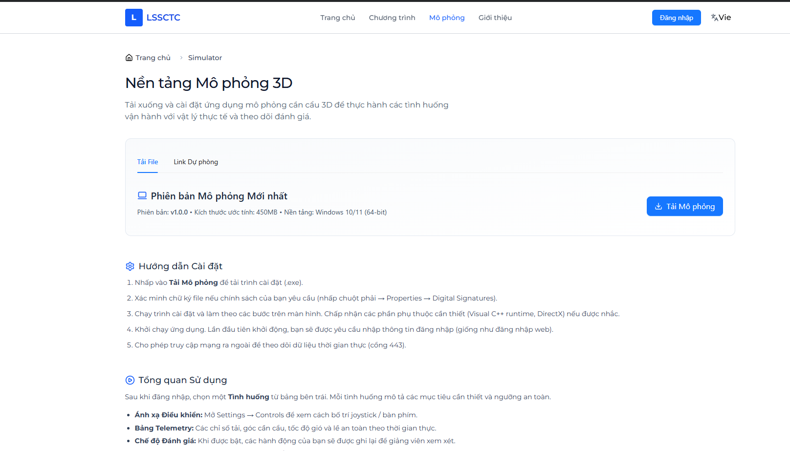

2. Open CraneSimulator.exe file

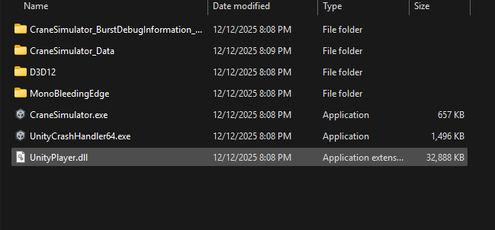

3. Login with username, password

  
 4. Select practice mode



5. Select Class

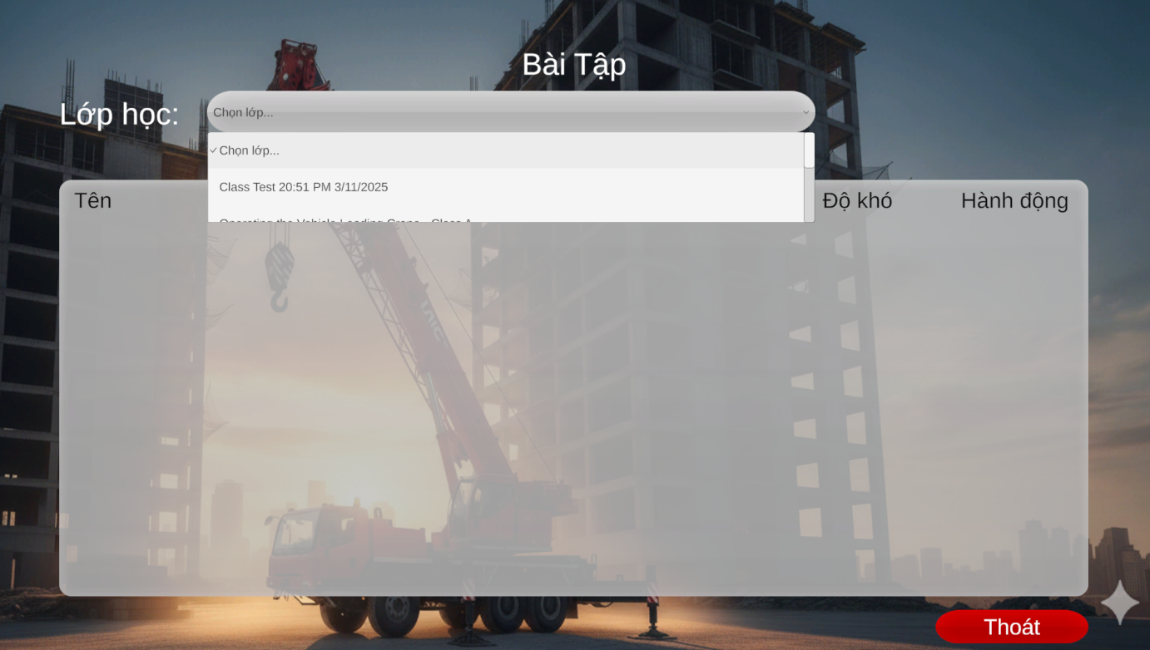

6. Select practice to start

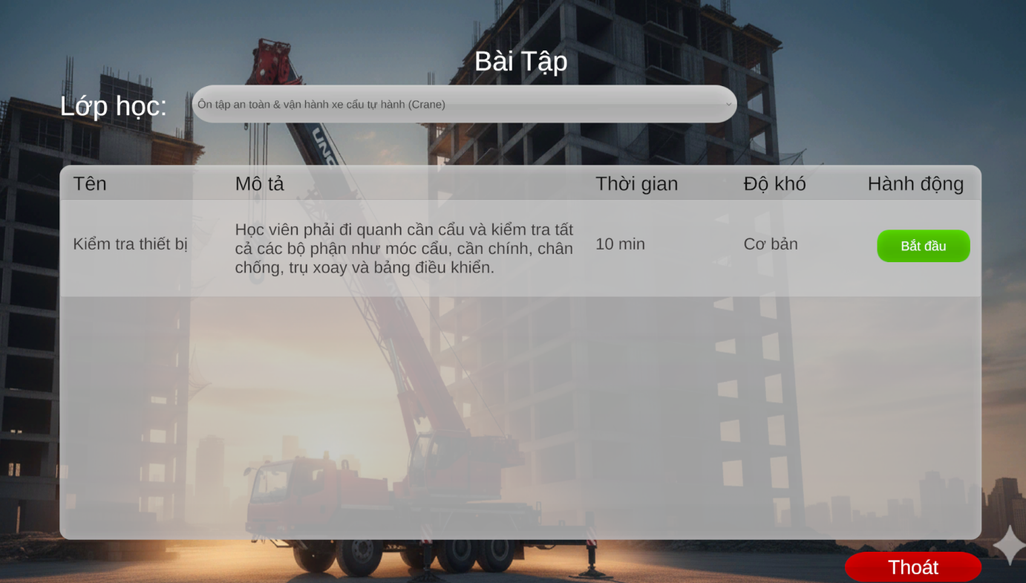

7. Finish practice

### 3.4 Troubleshooting

[Descript some common troubles while using application.]